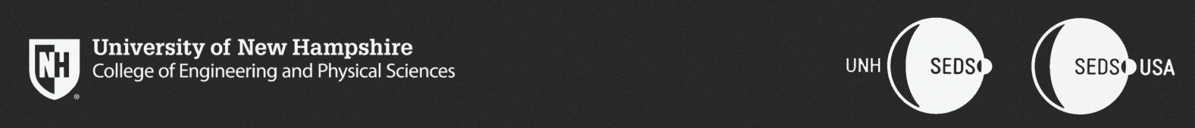  
  
CEPS Student Organization Budget Request  
**UNH Students for the Exploration and Development of Space**

To the CEPS Office of the Dean,

This year marks UNH SEDS’ 4th year being an organization on campus and within CEPS. We have fostered a community of space-loving students within our home of Kingsbury S172 as well as within our community in CEPS, UNH and the surrounding community. We have hosted 29 senior projects within EE, CE, and ME in just three years. We have successfully designed, manufactured and tested a hybrid rocket engine in preparation for the Spaceport America Cup Competition taking place annually in June, and will continue to optimize the engine into a safe flight ready design. Lastly, and most importantly, we have created a community that is not reset year-to-year based on senior projects, but is run by all majors and years to create a growing community within the CEPS college.

There will be 6 seniors working on their senior projects in SEDS. More than half the senior members using this organization as their senior project have been in the club since the start. Many of UNH SEDS alumni have graduated and went on to work in the aerospace industry for companies like Space X, Rocket Lab, Department of Defense, Turbocam Int., and Raytheon. SEDS also has built many good relationships with local business that help cut the costs of manufacturing and share valuable industry expertise to help with our engineering projects.

Within our budget sheet, we took the liberty to explain each section/sub-section to ensure you understand the ‘why’ of each objective and how the resources listed are critical for its completion. In addition, more than half of the funds we have within our budget contribute to our engineering projects as there will be no travel permitted by the school this year. It is also important to note here that machining expenses are not listed in the budget as we are confident that the relationships we have currently with companies will allow us to utilize the machines and machining time we need for our parts. UNH SEDS has a goal of promoting the Aerospace Industry to the CEPS community. We feel this industry is truly underrepresented here at UNH during a time when the industry is rapidly expanding. The commercial space industry is currently the hardest engineering industry to get into (~1%), having practical experience and meeting the right people is part of the game. It is a necessity for not a well-known school like UNH in terms of engineering.

For the reason above, we have chosen to ask the CEPS Office of the Dean $**11,101.40** to support the 16 members currently (and expecting four new members to travel, as well) to attend SpaceVision.

If there are any questions within this packet of information on the story of SEDS and our goals, please do not hesitate to contact the team or myself.

Sincerely,

Alex Chesley